Chioma Jennifer Obikili

Data Visualization with Python

Exercise 1.1

1. *Read your Achievement 1 project brief (PDF) and create a sample timeline for achieving key project milestones with a deadline of X weeks (your personal goal for completing the Achievement). You can use this timeline template (PDF) or a project management tool of your choice.*



1. *Reflect on what challenges you might encounter while working on this project as a freelancer.*
   1. *What are the pros and cons of working on your own timeline?*
   2. *What strategies will you use to hold yourself accountable?*
   3. *Write 150 to 200 words about your thoughts on this Exercise’s content in a text document.*

Creating and following my own timeline has some good and bad sides. One big benefit is that it gives me the freedom to plan tasks around my daily life, especially as a stay-at-home mom. I can work during quiet times, adjust for any changes at home, and move at my own pace. This makes the project feel less stressful and more doable.

But working alone also has challenges. Without someone checking in on me or setting deadlines, it can be easy to put things off or lose focus. To stay on track, I will use daily to-do lists and set small goals with deadlines. I also plan to set aside regular time each day to work on the project. At the end of each week, I’ll check my progress to stay motivated and make sure I’m moving forward.

Using a timeline helps me see what I’ve done and what’s left, which keeps me focused and organized. These strategies will help me finish my project, even with the busy schedule of caring for my daughter.

1. *Install JupyterLab and explore its functionalities. Reflect on what you notice in terms of differences (good or bad) compared to Jupyter Notebook. Take a screenshot of a JupyterLab session and paste it into your text document.*

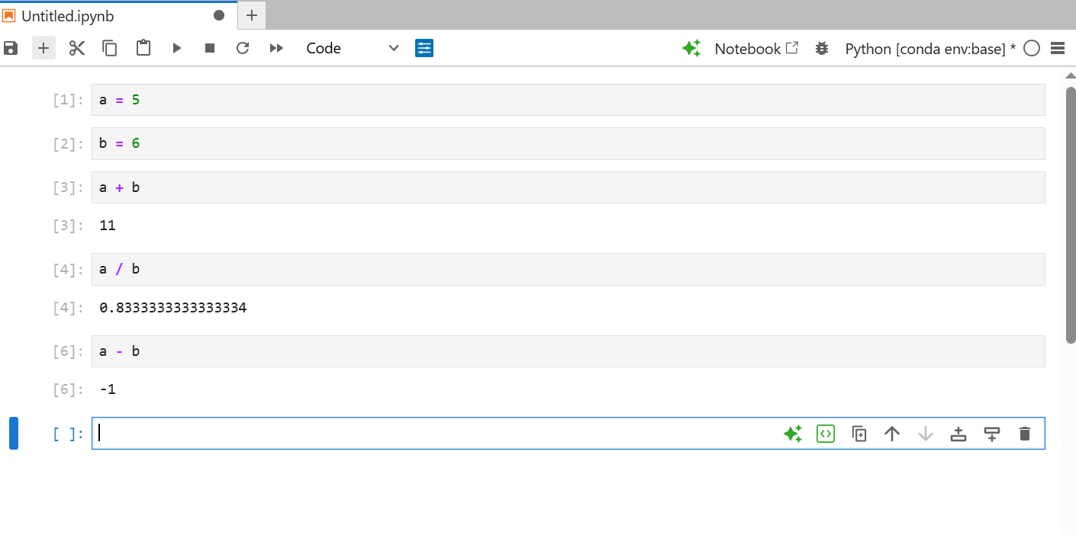

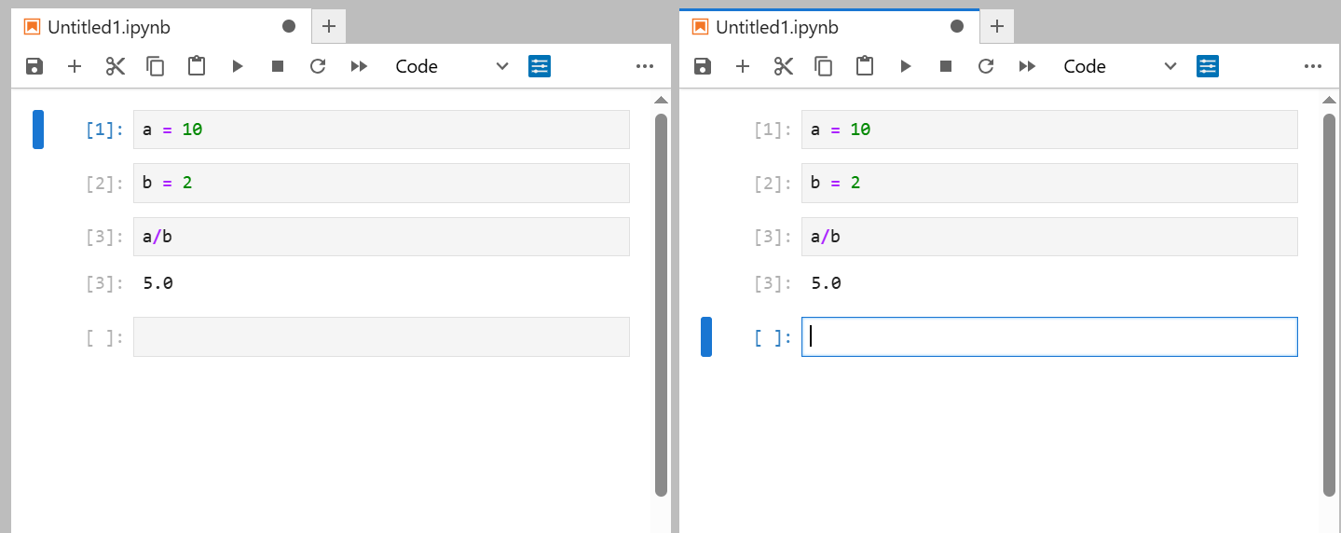

JupyterLab seems to be an upgraded version of Jupyter Notebook. It lets me open several files and tools at once in one window, which saves time and keeps everything in one place. I can work with notebooks, text files without switching tabs. It seems a bit confusing because of all the features, but I intend to get used to it. Compared to Jupyter Notebook, JupyterLab feels more advanced and better for big projects, while the Notebook is simpler and easier for quick work.

1. Get started with Google Colab and try executing some basic code, for example, some basic addition and division between numbers. Take a screenshot of the notebook and paste it into your text document.

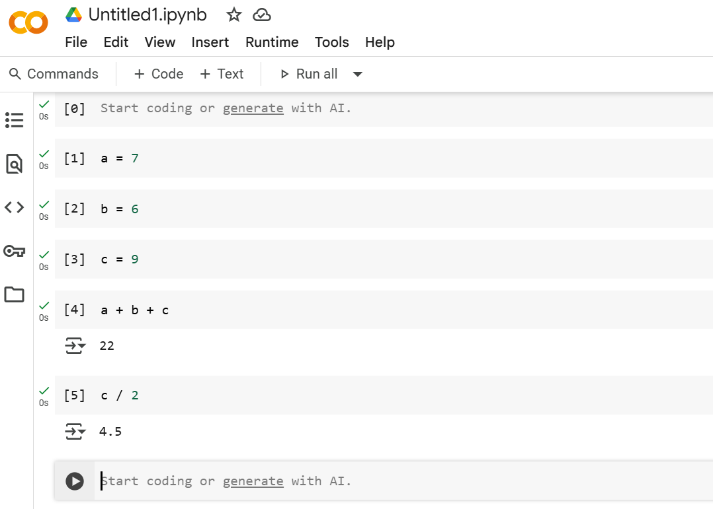

1. *Write 150 to 200 words about the pros and cons of using JupyterLab and Google Colab in your text document. Create a scenario where you think JupyterLab would be the best tool to use, then do the same for Google Colab.*

JupyterLab and Google Colab are both tools that help you write and run Python code, but they work in different ways.

JupyterLab is used on your own computer. It’s great if you have files saved locally and want to keep everything organized in one place. You can open notebooks, folders, and terminals all in the same window. But it takes some time to install and may not work well if your computer is slow.

Google Colab runs online in your browser. You don’t need to install anything. It’s easy to use, great for beginners, and you can share your work with others quickly. But it needs internet to work, and sometimes it disconnects if you’re not active for a while. Also, the disk space for temporary working memory is just 15 GB for users with a standard Google Drive subscription, which wouldn’t be sufficient for larger data sets

**When to use JupyterLab:** If you’re working on a big project with many files and you want to use tools that are saved on your computer, JupyterLab is the better choice.

**When to use Google Colab:** If you’re working with someone else especially (collaborating with other analysts) or using a different computer, Colab is great because you can open your notebook from anywhere and work together online.